Please note that I mixed the 2 questions into 1 project. (I added the textures and then moved the rectangles with the textures)

1st Run: Static Rectangles with Texture

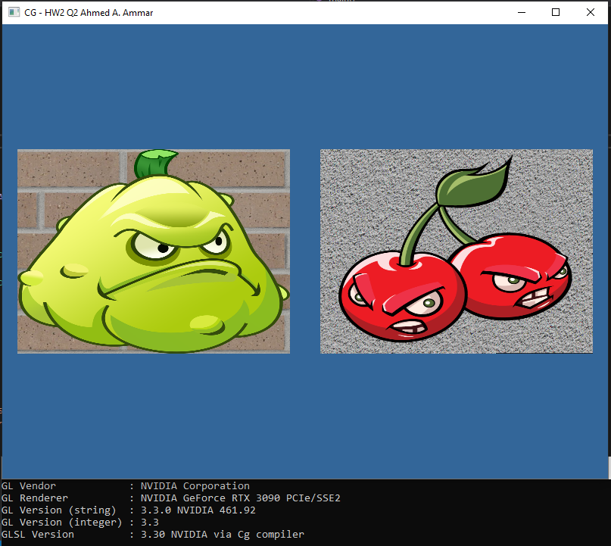

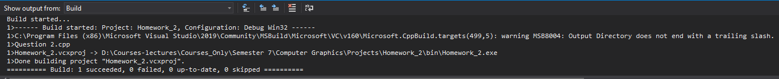

2nd Run: Moving Rectangles with Textures

The movement was done via a vec2 uniform called “transform” in the vertex shader “basic.vert”. The uniform is to be changed over time as its components get added to the position components in the vertex shader.



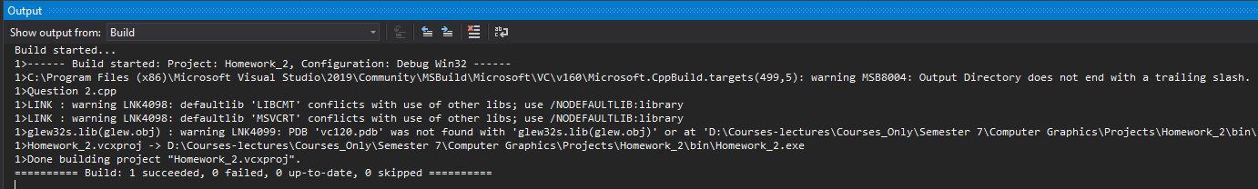

Pictures Citation: All of the following are copyright-free.

1. plant.png: <https://www.pngitem.com/middle/iibbm_plants-vs-zombies-png-image-plants-vs-zombies/>
2. cherrybomb.png: <https://www.pngwing.com/en/free-png-detwg>